**Version 2**

As we did not get good accuracies in the base version, we did some changes in next version. Added few more images and remove some of the images from old set, so total images set was of 113 records - 94 in training and 19 in validation.

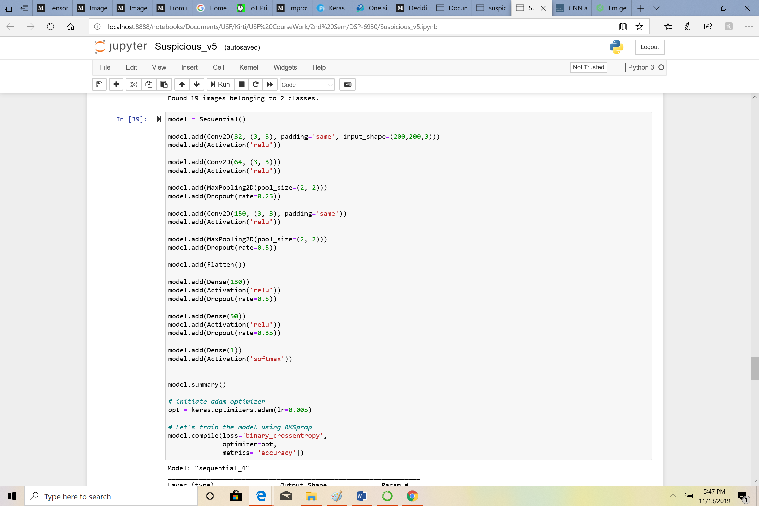

Used epochs = 10, Batch size for training and validation set as 10. As steps_per_epoch is dependent on total images/batch size so modified it to training steps per epoch = 11 and 11 in validation steps and got accuracy of 56% and validation accuracy of 46-47%.

